

**ICC Project Proposal.**

**BCS-7K.**

**Project Title:**

**AI-Sentiment Analysis Website**

**Group Members:**

Syeda Hajra 21K-3310

Zohaib Saqib 21K-3215  
Atif Ali 21K-3340

Muhammad 21K-3192

Murtaza Ahmed 21K-3440

**Project Idea:** AI-Enhanced Personal Journal and Mood Tracker

**Description:**

Create a unique personal journal and mood tracking platform that incorporates artificial intelligence (AI) for sentiment analysis and content recommendations. This project is designed to help users maintain a journal, track their emotions, and receive personalized insights.

**Features and Components:**

**User Profiles:** Allow users to create profiles and enter their details.

**Journal Entries:** Implement a database to store user journal entries, including text and timestamps.

**Mood Tracking:** Enable users to log their daily emotions, feelings, or moods. The database will store this mood data over time.

**AI Sentiment Analysis:** Use AI (Chatgpt API) for sentiment analysis of journal entries to determine the user's emotional state.

**Content Recommendations:** Provide personalized content recommendations based on the user's moodand past journal entries. For example, if a user is feeling down, recommend uplifting articles, music, or quotes.

**Data Visualization:** Create graphs and visualizations to display mood trends and patterns over time.

**User Engagement:** Implement gamification elements, challenges, or rewards to encourage regular journaling and mood tracking.

**System Architecture:**

The system architecture follows a client-server model. The client side encompasses a web interface designed for intuitive user interaction and seamless navigation. The server side involves robust backend services handling user authentication, data storage, sentiment analysis, and content recommendation engines. The backend incorporates scalable databases and APIs to ensure efficient data processing and retrieval.

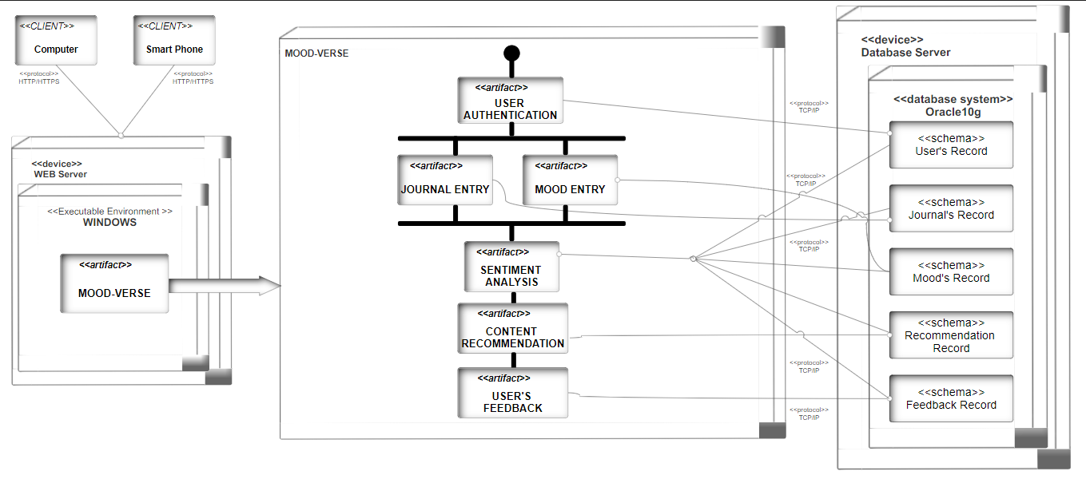

**Advantages:**

**Personal Growth:** This project can help users gain insights into their emotions and promote personal development.

**AI Integration:** AI-enhanced features make the project innovative and relevant to emerging technology trends.

**User Data Analysis:** The project can focus on analyzing user data to provide valuable insights into emotional well-being and behavior patterns.

**Positive Impact:** Promoting mental health and well-being is a socially impactful use of technology.